Daily Market Analysis
Market Focus

US equities fell hard on Thursday as the markets renewed their previous optimism, driven by a slew of strong earnings, took a turn down after Facebook Meta Platforms’ disappointing earning report on Wednesday. The Dow Jones Industrail Average dropped 1.4% while the S&P 500 slided 2.4%, the wirst day in nearly a year. In the meantime, the tech heavy weighted Nasdaq fell 3.7% for its worst day since late 2020.
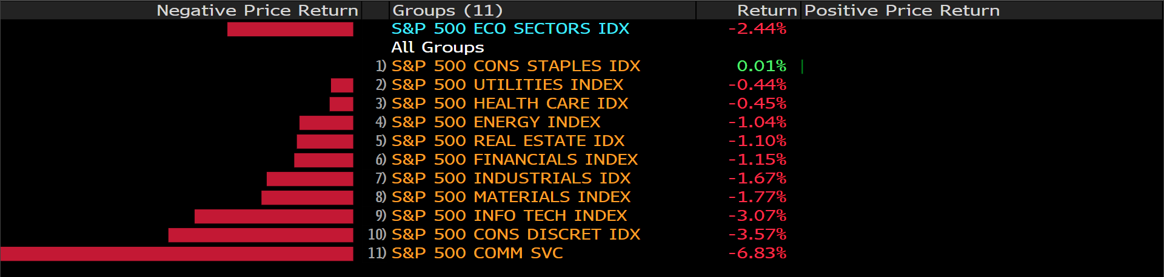
Bloomberg
On “Super Thursday,” European Central Bank decided to keep interest rates unchanged even though the most recent inflation figure has git a record 5.1%. The latest European Central Bank’s forecasts point to the inflation is 3.2% this year, which is above the target rate. The central bank believes that the inflation will be cool down followed by a promising hawkish pivot.

Meanwhile in the UK, the bank of England raised its interest rates for the second time in a quarter. The BOE decided to hike its rate to 0.5% from previous 0.25%. Having UK consumer prices rose to 5.4% in December, the highest in nearly 30 years, the BOE expected that the inflation rate will possibly peak at around 7.25%; the markets are now betting the BOE will hike its rate to 1.5% by mid 2023 in order to combat the inflation.

Main Pairs Movement:

GBPUSD’s bulls took a breather on Thursday, hitting as high as 1.36277 and up 0.04% at the end of the day. The British Pound was boosted as the Bank of England hiked the policy rates back-to-back to 0.5% from 0.25%. At the same time, the labor market in the UK remained robust, strengthening the Pound.

EURUSD was up 1.18% on Thursday, approaching January monthly high. The euro dollar outperformed following ECB President Lagarde’s hawkish comments, overturning from previous dovish stance.

Gold’s bulls were little affected by the Bank of England’s aggressive stance and the ECB’s hawkish comments on Thursday. Gold was once hitting as low as $1,788 and bouncing back above $1,800 at the end of the day.

Technical Analysis:

EURUSD (4- Hour Chart)
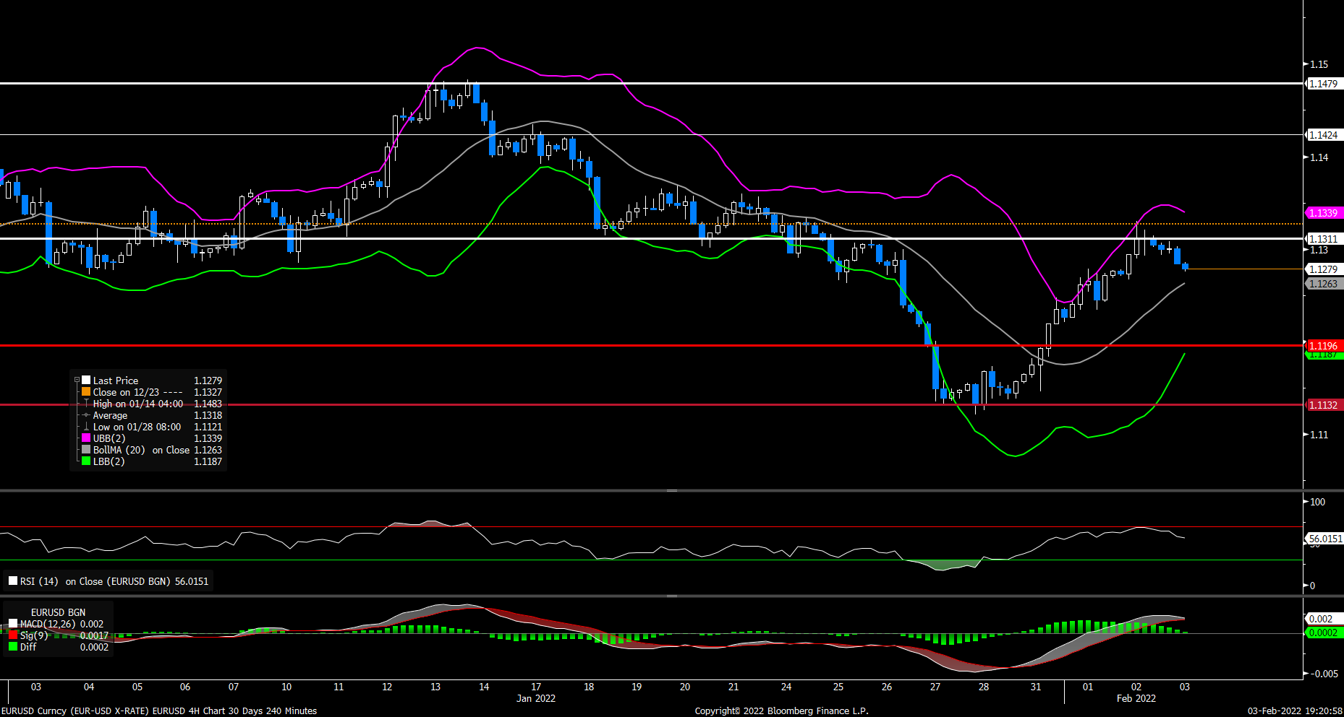
The EUR/USD pair declined on Thursday, continuing to retreat from a two-week high that touched earlier this week after four consecutive daily advances. The pair remained under pressure most of the day, dropping to a daily low below 1.1280 level during European session. The pair was last seen trading at 1.1278, posting a 0.21% loss on a daily basis. EUR/USD stays in the negative territory amid stronger US dollar across the board, as the DXY index reversed part of its recent pullback and climbed above 96.00. Despite the falling US bond yields, the greenback still managed to regain some upside momentum on Thursday. In Europe, market focus now shifts to ECB’s interest rate decision, which is expected to be unchanged but ECB President Christine Lagarde's comments on the inflation outlook will be also watched closely.

For technical aspect, RSI indicator 55 figures as of writing, suggesting bull movement ahead. But looking at the Bollinger Bands, the price dropped towards the moving average after touching the upper band, which indicates that the pair could remain its downside traction. In conclusion, we think market will be bearish as long as the 1.1311 resistance holds. On top of that, the pair could face renewed selling pressure if the ECB continues to push pack against rate hike bets.

Resistance: 1.1311, 1.1424, 1.1479
Support: 1.1196, 1.1132

GBPUSD (4- Hour Chart)
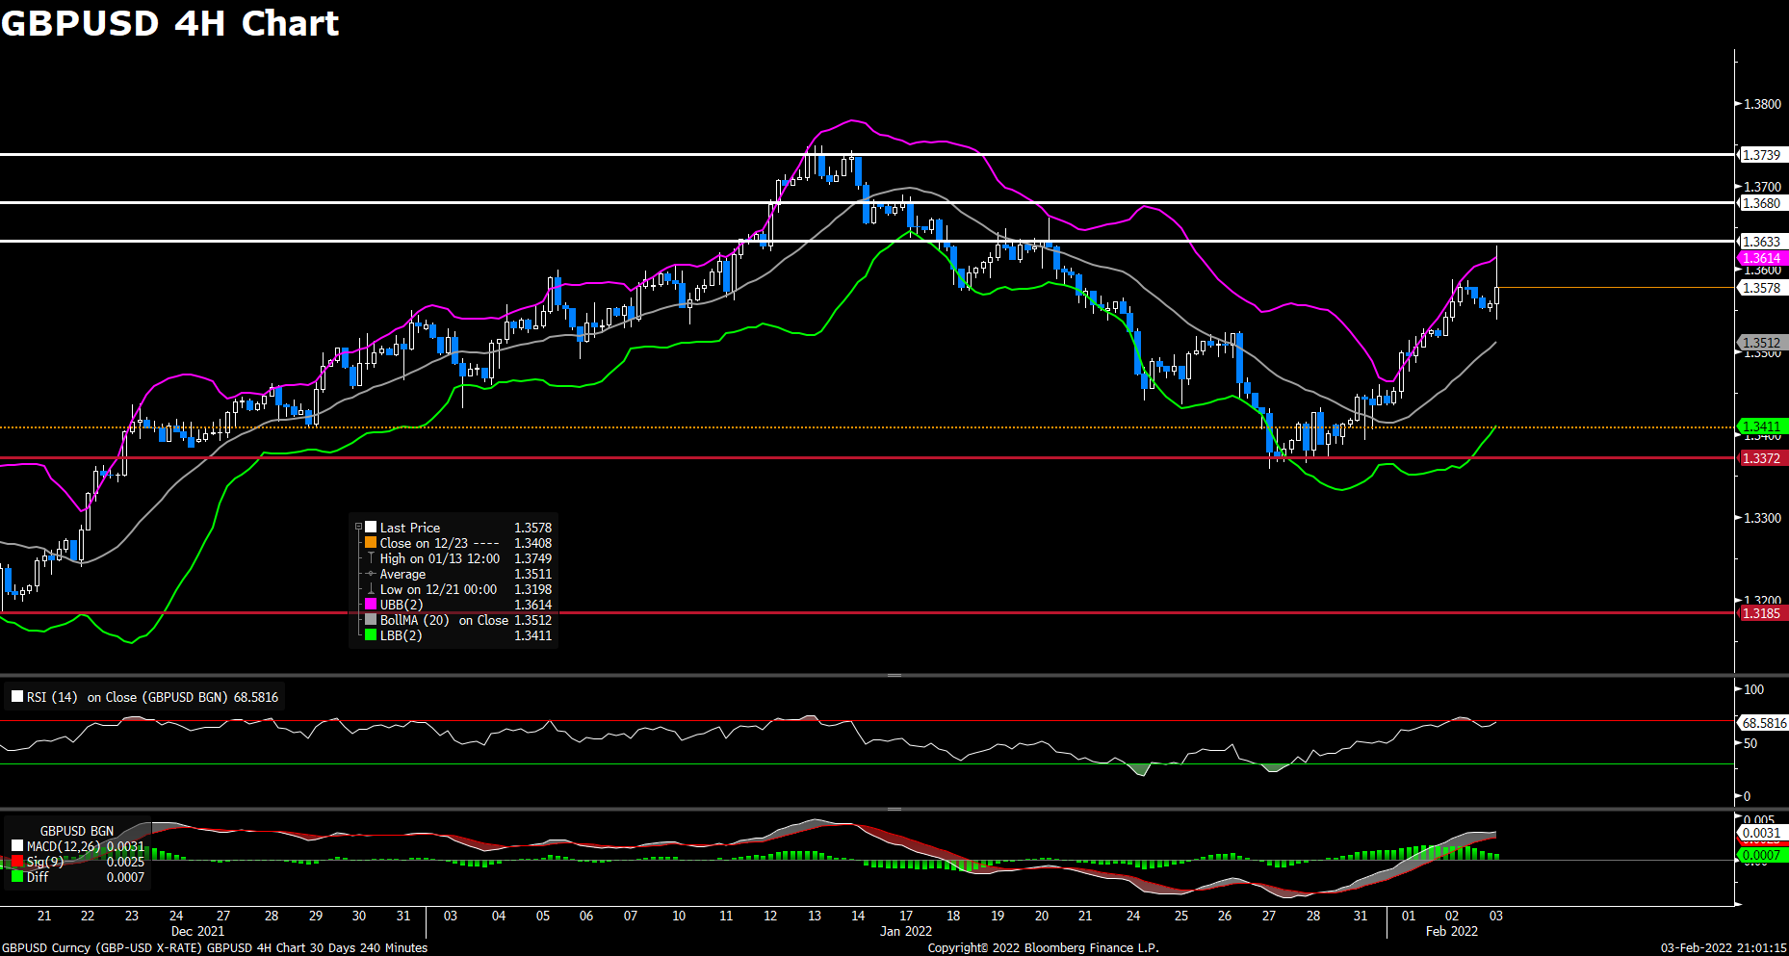
The pair GBP/USD advanced on Thursday, gaining bulish momentum to climb above the 1.3600 mark after the key BoE event. The pair failed to keep its traction after yesterday’s rally to 1.3590 area, once touching a daily low during European session. But the Bank of England’s monetary policy decision lend strong support to GBP/USD. At the time of writing, the cable stays in positive territory with a 0.26% gain for the day, recovering most of its intraday’s losses. The Bank of England raised the benchmark interest rate by 25bps to 0.50%, which was in line with market expectations and marked the first back-to-back interest rate rises since 2004. Moreover, traders await for BOE Governor Andrew Bailey’s speech for fresh hints on future rate hikes.

For technical aspect, RSI indicator 70 figures as of writing, suggesting that the pair is in overbought zone now, a trend reversal could be possible. As for the Bollinger Bands, the pair rebounded and failed to cross below the moving average, therefore the upside momentum should persist. In conclusion, we think market will be bullish amid the rate hike by BoE. If the BOE is hawkish about the inflationary outlook of the economy, this might push the cable to break through the 1.3633 resistance and set the stage for a further near-term upside move.

Resistance: 1.3633, 1.3680, 1.3739
Support: 1.3372, 1.3185

USDCAD (4- Hour Chart)
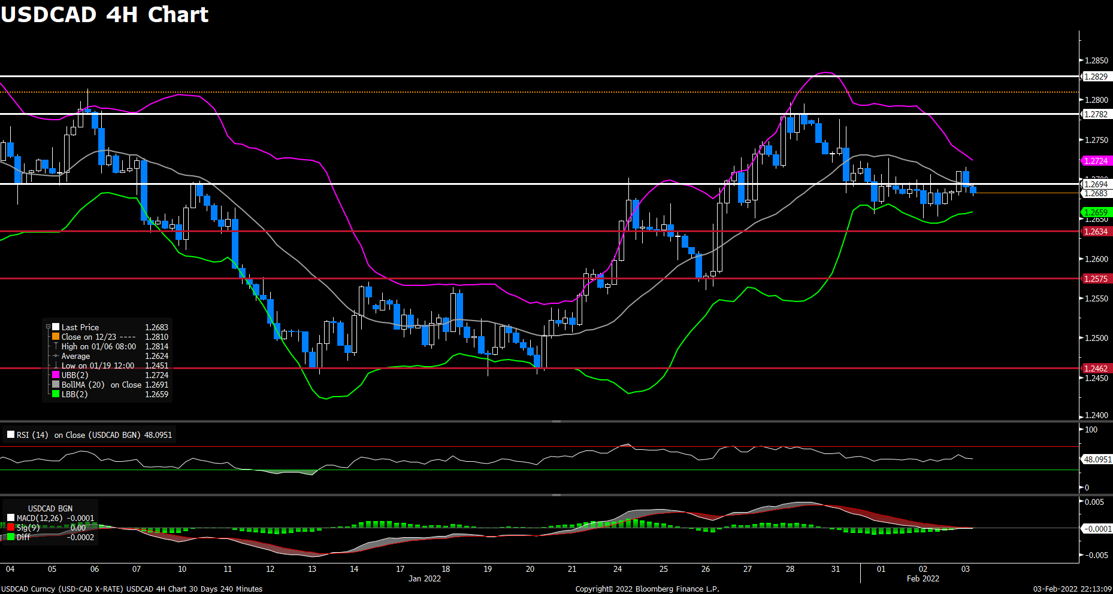
After three successive days of the losing streak to a one-week low below 1.266 level, the pair USD/CAD regained upside momentum on Thursday. The pair was trading higher in Asian session and touched a two-day high above 1.2710 level, now retreating back slightly to surrender some daily gains. The bullish momentum witnessed in USD/CAD is mainly due to US dollar strength, as the pair is currently rising 0.14% on a daily basis. The dismal US ADP report released yesterday provide some support for the greenback to make a solid comeback. On top of that, the retreating crude oil prices has also weighed on the commodity-linked loonie and acted as a tailwind for the pair, as WTI oil declined 0.48% for the day.

For technical aspect, RSI indicator 47 figures as of writing, suggesting that the downside appears more favored as the RSI sits below the midline. For the the Bollinger Bands, the pair is falling towards the lower band, therefore an downside movement could be expected. In conclusion, we think market will be bearish as long as the 1.2694 resistance line holds. The USD/CAD pair seems lacking bullish momentum and struggled to find acceptance above the 1.2700 mark at the moment.

Resistance: 1.2694, 1.2782, 1.2829
Support: 1.2634, 1.2575, 1.2462

Economic Data:

Currency | Data | Time (GMT + 8) | Forecast
GBP | Construction PMI (Jan) | 17:30 | 54.3
USD | Nonfarm Payrolls (Jan) | 21:30 | 150K
USD | Unemployment Rate (Jan) | 21:30 | 3.9%
CAD | Employment Change (Jan) | 21:30 | -117.5K
CAD | Ivey PMI (Jan) | 23:00

